**Table 1**.Scale for quality assessment

|  |  |
| --- | --- |
| **Criteria** | **Score** |
| **1.Gout-type described** |  |
| **described** | 1 |
| **no described** | 0 |
| **2.Quality control of genotyping methods** |  |
| **DNA sequencing** | 2 |
| **Taqman, HRM and so on** | 1 |
| **RFLP** | 0 |
| **3.Habits and customs or pathogenic factors described** |  |
| **both described** | 2 |
| **only one described** | 1 |
| **no described** | 0 |
| **4.Source of control** |  |
| **Population based** | 2 |
| **Hospital based** | 1 |
| **no described** | 0 |
| **5.case size** |  |
| **>=200** | 2 |
| **200>and>=100** | 1 |
| **<100** | 0 |
| **6.Hard-Weinberg equilibrium(HWE) in control** |  |
| **yes** | 1 |
| **no** | 0 |

When more than one genotyping method used in one study, we scored for the highest quality method.

**Figure 1**. Literature search and study selection

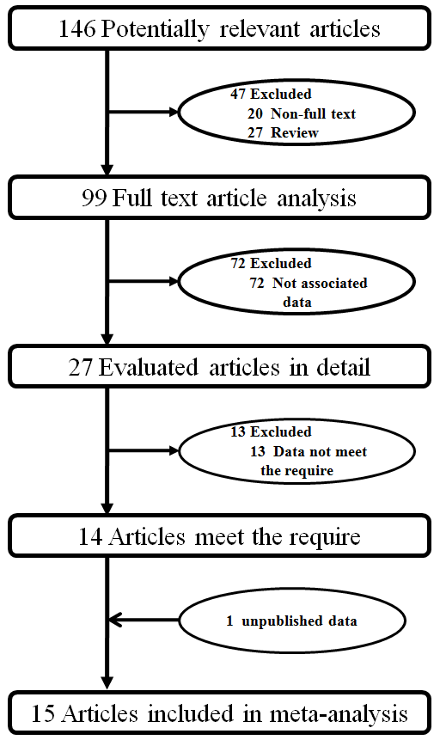

**Table 2**. Applicable conditions for genetic model

|  |  |  |
| --- | --- | --- |
| **Applicable conditions** | | **Suggest model** |
| OR | P |
| OR1=OR3≠1  and OR2 = 1 | POR1 and POR3<0.05,POR2>0.05 | recessive model |
| OR1=OR2≠1  and OR3 =1 | POR1 and POR2<0.05,POR3>0.05 | dominant model |
| OR2= 1/OR3≠1  and OR1=1 | POR2 and POR3<0.05,POR1>0.05 | overdominant model |
| OR1>OR2>1  and OR1>OR3>1 | POR1 ̖ POR2 and POR3<0.05 | codominant model |

**Table 3** Characteristics of including studies which have original data

|  |  |  |  |  |  |  |  |  |  |  |  |  |
| --- | --- | --- | --- | --- | --- | --- | --- | --- | --- | --- | --- | --- |
| **Study** | **Year** | **Country**  **of study** | **Continent** | **Ethnicity** | **HWE** | **Case/**  **contol** | **Male/female Ratio**  **Case control** | | **Mean age**  **Case control** | | **MAF**  **Case control** | |
| **Woodward(white)** | 2009 | USA | North America | Caucasian | No | 455/  8034 | - | - | - | - | 0.152 | 0.103 |
| **Stark** | 2009 | Germany | Europe | Caucasian | Yes | 683/  1563 | 2.37 | 1.26 | 58.3 | 58.5 | 0.137 | 0.104 |
| **Matsuo** | 2009 | Japan | Asia | Mongoloid | Yes | 159/  865 | All male | All male | - | - | 0.469 | 0.281 |
| **Phipps-Green**  **(Maori)** | 2010 | New zealand | Oceania | polynesian | Yes | 185/  284 | 2.79 | 0.48 | 39 | 40.8 | 0.107 | 0.097 |
| **Phipps-Green**  **(Eastern Polynesia)** | 2010 | - | Oceania | polynesian | Yes | 189/  277 | 2.86 | 0.50 | - | - | 0.107 | 0.090 |
| **Phipps-Green**  **(Western Polynesia)** | 2010 | - | Oceania | polynesian | Yes | 129/  71 | - | - | - | - | 0.519 | 0.275 |
| **Phipps-Green (Caucasian)** | 2010 | New zealand | - | Caucasian | Yes | 214/  562 | 6.25 | 0.69 | 46.2 | 44.6 | 0.242 | 0.126 |
| **Phipps-Green**  **(Pacific Island)** | 2010 | New zealand | Oceania | polynesian | Yes | 173/  129 | 22.3 | 1.18 | 33.5 | 37.7 | 0.439 | 0.202 |
| **Yamagishi** | 2010 | Japan | Asia | Mongoloid | No | 45/  3878 | 4.60 | 0.63 | - | - | 0.467 | 0.311 |
| **Li** | 2011 | China | Asia | Mongoloid | Yes | 200/  235 | All male | All male | 56.0 | 42.3 | 0.453 | 0.323 |
| **Guan** | Unpub | China | Asia | Mongoloid | Yes | 201/  200 | 11.56 | 0.70 | 58 | 51 | 0.54 | 0.30 |

Unpu means this study have not published before.

**Table 4**. Identified genetic model in subgroup

|  |  |  |  |  |  |  |  |  |  |  |  |  |
| --- | --- | --- | --- | --- | --- | --- | --- | --- | --- | --- | --- | --- |
|  | | | **OR1** | | | **OR2** | | | **OR3** | | | **Suggest model** |
|  | condition | subject | OR | 95%CI | P | OR | 95%CI | P | OR | 95%CI | P |  |
| **Overall** | 11 | 4.30 | 3.069-6.037 | 0.00 | 1.70 | 1.405-2.059 | 0.00 | 2.36 | 1.707-3.250 | 0.00 | codominant |
| **Year** | **2009** | 3 | 2.81 | 1.765-4.484 | 0.00 | 1.82 | 1.252-2.652 | 0.00 | 1.34 | 0.942-1.920 | 0.10 | dominant |
| **2010** | 6 | 5.78 | 3.672-9.084 | 0.00 | 1.70 | 1.233-2.350 | 0.00 | 3.13 | 1.997-4.907 | 0.00 | codominant |
| **2011-** | 2 | 5.29 | 2.488-11.230 | 0.00 | 1.50 | 1.103-2.036 | 0.01 | 3.47 | 2.187-5.521 | 0.00 |
| **HWE** | **Yes** | 9 | 4.83 | 3.290-7.087 | 0.00 | 1.76 | 1.377-2.241 | 0.00 | 2.48 | 1.673-3.675 | 0.00 |
| **No** | 2 | 2.89 | 1.725-4.859 | 0.00 | 1.55 | 1.259-1.908 | 0.00 | 2.04 | 1.031-4.022 | 0.04 |
| **Continent** | **Non-asian** | 7 | 4.15 | 2.222-7.759 | 0.00 | 1.63 | 1.322-2.015 | 0.00 | 2.10 | 1.422-3.107 | 0.00 |
| **Asian** | 4 | 4.56 | 3.235-6.429 | 0.00 | 1.80 | 1.172-2.778 | 0.01 | 2.54 | 1.442-4.479 | 0.00 |
| **Number** | **>1000** | 4 | 3.07 | 2.141-4.397 | 0.00 | 1.74 | 1.255-2.408 | 0.00 | 1.58 | 1.104-2.256 | 0.01 |
| **<1000** | 7 | 5.95 | 4.067-8.694 | 0.00 | 1.68 | 1.294-2.178 | 0.00 | 3.39 | 2.406-4.775 | 0.00 |
| **Ethnicity** | **Caucasian** | 3 | 2.80 | 1.513-5.182 | 0.00 | 1.61 | 1.308-1.975 | 0.00 | 1.66 | 1.042-2.648 | 0.03 |
| **Mongolold** | 4 | 4.56 | 3.235-6.429 | 0.00 | 1.80 | 1.172-2.778 | 0.01 | 2.54 | 1.442-4.479 | 0.00 |
| **Polynesian** | 4 | 8.20 | 4.008-16.791 | 0.00 | 1.67 | 1.030-2.704 | 0.04 | 3.66 | 1.791-7.498 | 0.00 |
| **Quality** | **Low** | 4 | 3.83 | 1.927-7.617 | 0.00 | 1.56 | 1.206-2.011 | 0.00 | 2.25 | 1.420-3.555 | 0.00 |
| **High** | 7 | 4.59 | 3.052-6.894 | 0.00 | 1.78 | 1.353-2.332 | 0.00 | 2.40 | 1.534-3.750 | 0.00 |
| **Gender** | **Male** | 6 | 4.02 | 2.948-5.477 | 0.00 | 1.84 | 1.351-2.509 | 0.00 | 2.06 | 1.274-3.329 | 0.00 |
| **Female** | 4 | 4.20 | 1.981-8.918 | 0.00 | 1.26 | 0.805-1.962 | 0.31 | 4.17 | 1.118-15.579 | 0.03 | recessive |
| **Overall** | 10 | 4.04 | 3.032-5.384 | 0.00 | 1.68 | 1.286-2.182 | 0.00 | 2.34 | 1.467-3.746 | 0.00 | codominant |
| **Age** | **>46** | 5 | 4.20 | 3.153-5.598 | 0.00 | 1.69 | 1.218-2.349 | 0.00 | 2.29 | 1.392-3.780 | 0.00 |
| **<46** | 3 | 7.33 | 3.768-14.266 | 0.00 | 1.81 | 1.114-2.940 | 0.02 | 3.16 | 1.597-6.239 | 0.00 |
| **Overall** | 8 | 4.66 | 3.583-6.054 | 0.00 | 1.74 | 1.348-2.234 | 0.00 | 2.45 | 1.668-3.612 | 0.00 |

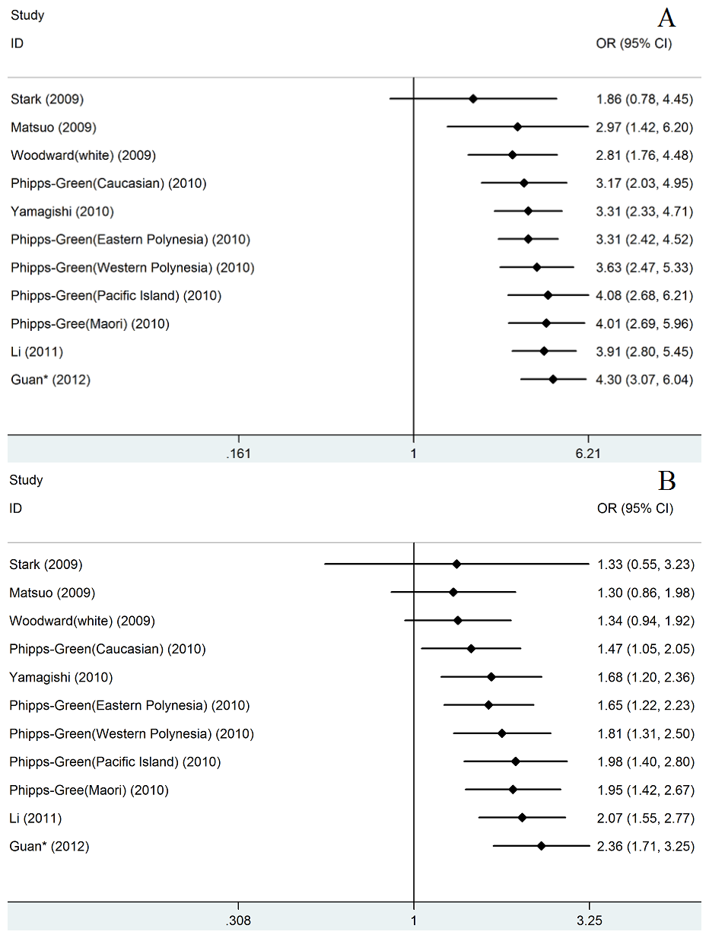

**Figure 2**. Cumulative meta-analysis of associations between the SNP rs2231142 and gout sorted primarily by published year. (A) in OR1 model(TT Vs GG); (B) in OR3 model(TT Vs GT).

**Table 5**.The result of meta-regression in OR1 and OR2 model

|  |  |  |  |  |  |  |  |  |  |  |
| --- | --- | --- | --- | --- | --- | --- | --- | --- | --- | --- |
|  | **LogOR** | **t** | **P>|t|** | **[95% Conf. Interval]** | | **I2** | **^I2** | **Tau2** | **^tau2** | **R2** |
| **O**  **R**  **1** | Sex | -0.44 | 0.67 | -1.20057 | 0.8143707 | 0 | 5.13% | 0 | 0 | .% |
| **Year\*** | 1.97 | **0.08** | -0.040956 | 0.6035375 | 40.50% | 21.51% | 0.1182 | 0.05429 | 59.01% |
| HWE | 1.24 | 0.245 | -0.405668 | 1.397079 | 40.50% | 35.62% | 0.1182 | 0.1111 | 16.13% |
| Continent | 0.33 | 0.752 | -0.720659 | 0.9627413 | 40.50% | 44.50% | 0.1182 | 0.1675 | -26.51% |
| Age* | -1.33 | 0.231 | -0.08072 | 0.0237599 | 34.40% | 29.72% | 0.0819 | 0.07339 | 7.96% |
| Quality | 0.49 | 0.633 | -0.6935492 | 1.081059 | 40.50% | 43.36% | 0.1182 | 0.1562 | -17.95% |
| Quality* | 0.07 | 0.943 | -0.3841871 | 0.4097663 | 40.50% | 45.93% | 0.1182 | 0.1804 | -36.23% |
| Number* | -2.12 | 0.063 | -0.000234 | 7.69E-06 | 40.50% | 18.33% | 0.1182 | 0.04515 | 65.91% |
| **O**  **R**  **3** | Sex | -0.92 | 0.386 | -2.035447 | 0.876886 | 51.90% | 53.33% | 0.2512 | 0.2143 | -8.91% |
| **Year\*** | 3.49 | **0.007** | 0.1361756 | 0.6397529 | 37.90% | 0.00% | 0.1014 | 0 | 100.00% |
| HWE | 0.46 | 0.656 | -0.767962 | 1.161357 | 37.90% | 43.31% | 0.1014 | 0.149 | -20.32% |
| Continent | 0.34 | 0.744 | -0.690765 | 0.9322637 | 37.90% | 43.56% | 0.1014 | 0.1477 | -19.32% |
| Age* | -1.32 | 0.235 | -0.084776 | 0.0253756 | 48.10% | 35.79% | 0.1365 | 0.1042 | 25.74% |
| Quality | 0.05 | 0.959 | -0.8548063 | 0.8957059 | 37.90% | 44.11% | 0.1014 | 0.1508 | -21.75% |
| Quality* | -0.65 | 0.529 | -0.4705011 | 0.2592886 | 37.90% | 38.46% | 0.1014 | 0..1384 | -11.77% |
| Number* | -1.22 | 0.254 | -0.000225 | 0.0000674 | 37.90% | 35.00% | 0.1014 | 0.1196 | 3.43% |

*means those factors were treated as Continuous variables.

^means the result after meta-regression.

In the meta-regression of published year , we default the Guan’ study published in 2012.

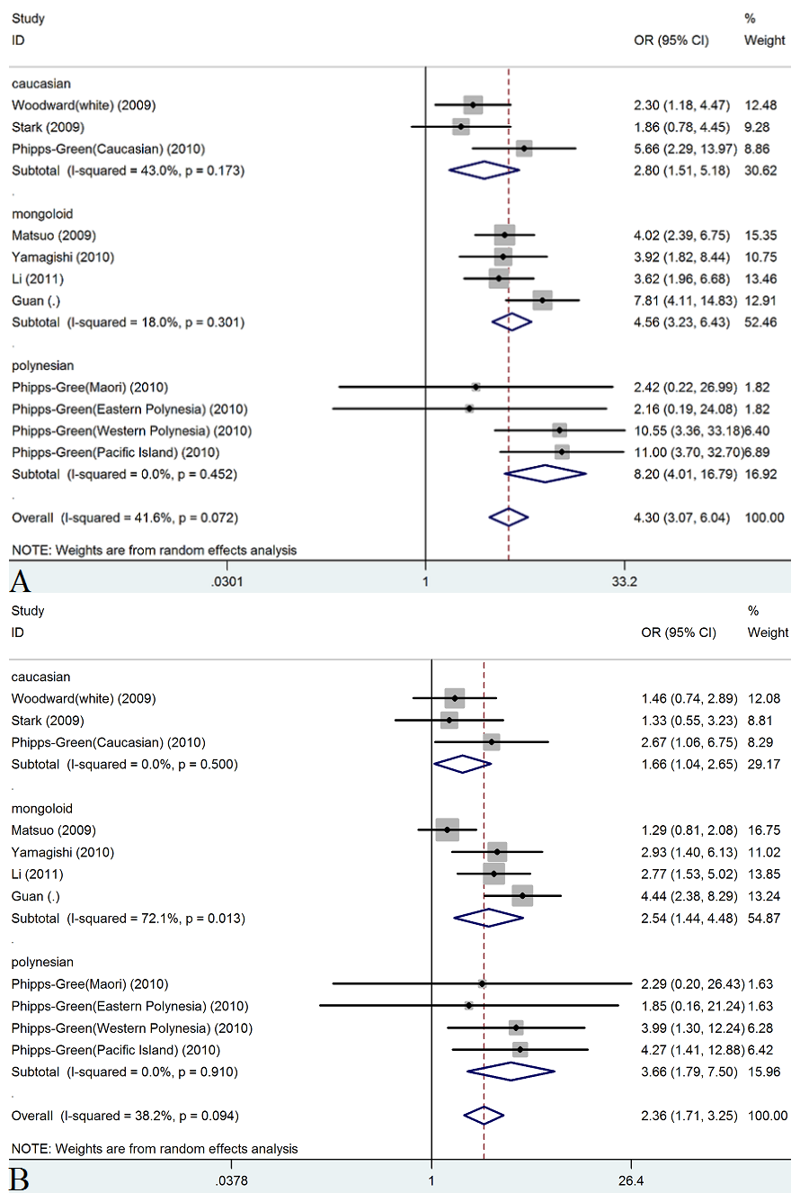

**Figure 3**. Forest plots for rs2231142 with gout in codominant model in different ethnicities. (A) in OR1 model(TT Vs GG); (B) in OR3 model(TT Vs GT)

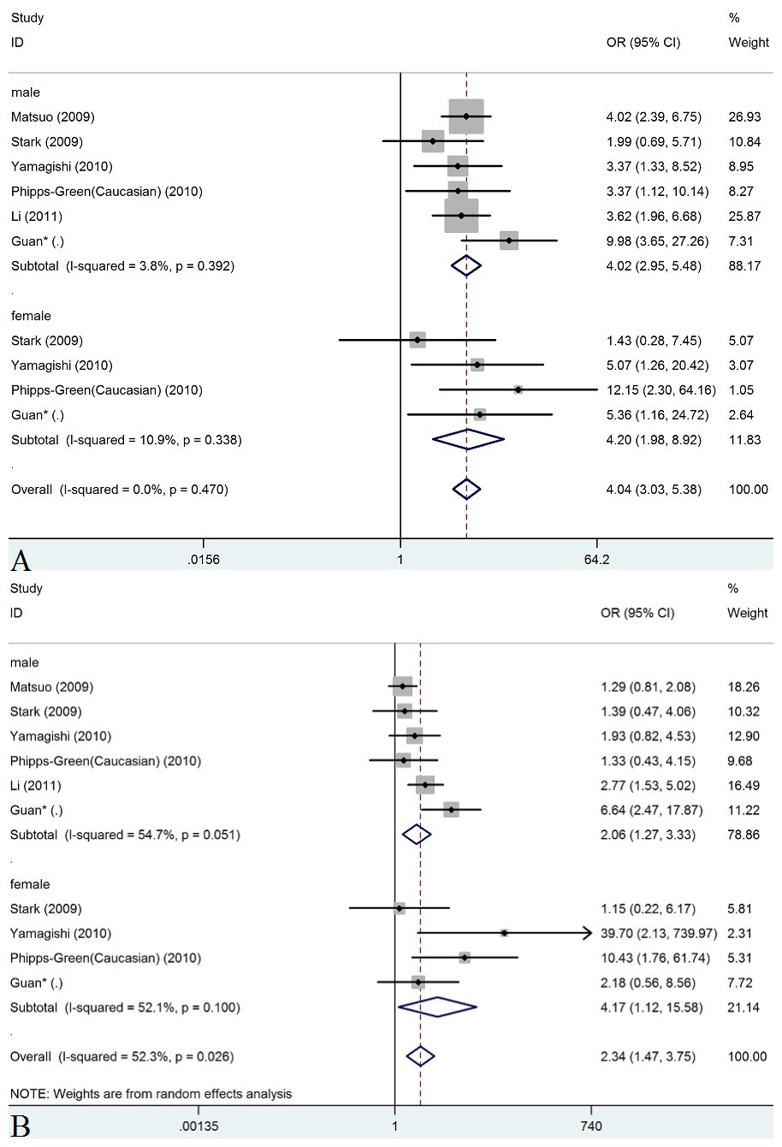

**Figure 4**. Forest plots for rs2231142 with gout in codominant model in different gender. (A) in OR1 model(TT Vs GG);(B) in OR3 model(TT Vs GT).

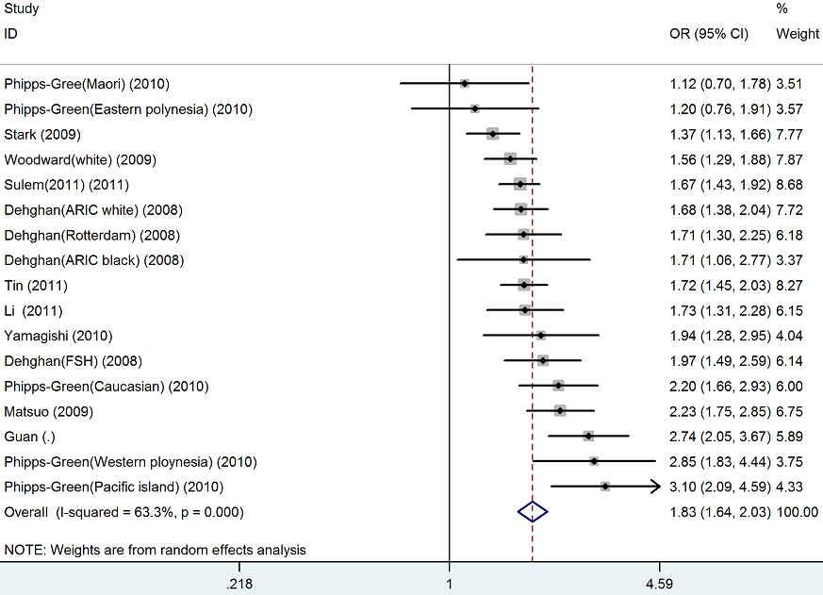

**Figure 5**. Forest plots for rs2231142 with gout in additive model

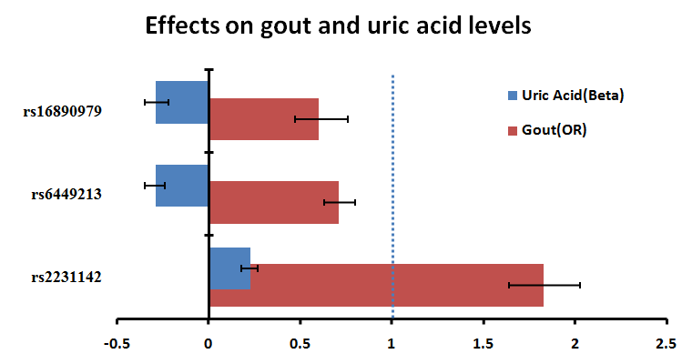

**Figure 6**. Relationship of three SNPs between uric acid and gout.

The standard error of value could be represent by 95%CI.